Open Hostess Night!!

Want to hostess to earn free products? Not sure if you want all those people in your house? Have them over to my house instead! Open hostess night at my home and you invite your friends and family to my house!! I do the cleaning food preparation and dish washing and you get the hostess credit and gifts without all the work!

To schedule yours today just give a call or email today and we’ll book your date and time. Get your spot now they are going fast!


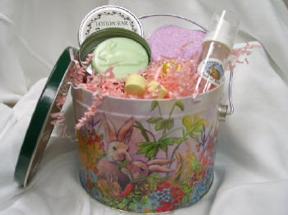
Your Independent Rep:
Name and ID number
(000) 000-0000
youremail@yourserver.com

Get your hostess gift today!!

