May and June Hostess bucket of fun May and June HOSTESS BUCKET of fun
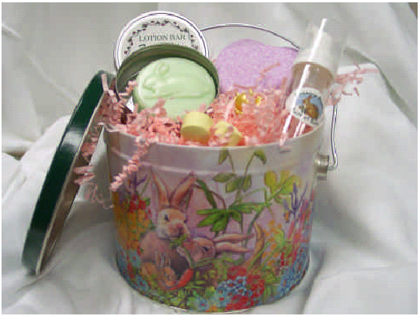
Host a Famous Country Bunny Bath and Body Spa Show Host a Famous Country Bunny Bath and Body Spa Show
*Shows with over $100 in sales enjoy 10% in free product. *Shows with over $100 in sales enjoy 10% in free product.
*Spa Show is over $200 *Spa Show is over $200
Adorable Bucket Adorable Bucket
Fresh Melon Lotion Bar Fresh Melon Lotion Bar
Heart Shaped Bath Bomb, Heart Shaped Bath Bomb,
Honeysuckle Bomblet Samples Honeysuckle Bomblet Samples
Safflower Bath Oil Bead Sample. Safflower Bath Oil Bead Sample.
*Spa Show is over $300 *Spa Show is over $300
Receive an additional Mini Foamer. Receive an additional Mini Foamer.
Call me to book your Spa Show today: Call me to book your Spa Show today:

