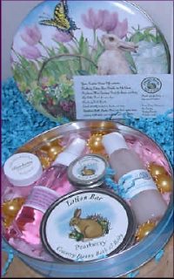 | Hostess Gift Set for  March and April  With a $200 show your tin includes:  - Bunny Tin  - Pearberry Lotion Bar  - Lip Cube  - Pearberry Mini Spritzer  - Sun Bath Oil Beads  - Pearberry Salt Sample  If your show reaches $300, you receive an additional gift of:  - Vanilla Mini Shower Gel  Book your Spa Show or Catalog Show today!
Rep Sign On Bonus Gift  Enjoy this darling Bunny for your spa table. She is holding one  of our original heart bath bombs.  You set also includes 5 opportunity flyers And 25 of our new product  catalogs.  It is a bonus to be a bunny! | 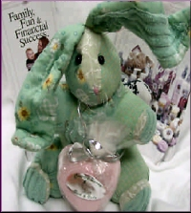

Your Country Bunny Bath & Body Representative:
Belinda Johnson #2510
816-230-1698, 816-582-2391 PCS
Order Online! http://www.cbunny.com/rephome.php?repsys=1574
Email: Belinda@bestofboards.com

