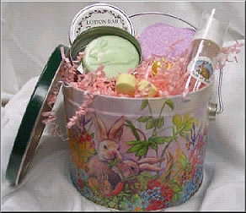
May/June Country Bunny Bath & Body Hostess Gift
Spa Show is over $200  Adorable Bucket  1 Fresh Melon Lotion Bar  1 Heart Shaped Bath Bomb,  2 Honeysuckle Bomblet Samples  1 Safflower Bath Oil Bead Sample | 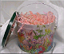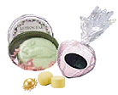
Spa Show is over $300  Receive a Mini Foamer too! | 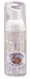

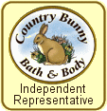
Call me to book your Spa Show today:

May/June Country Bunny Bath & Body Hostess Gift

Spa Show is over $200

Adorable Bucket

1 Fresh Melon Lotion Bar
1 Heart Shaped Bath Bomb,
2 Honeysuckle Bomblet Samples
1 Safflower Bath Oil Bead Sample

Spa Show is over $300
Receive a Mini Foamer too!

Call me to book your Spa Show today:

